Access Airflow UI
Open in your browser:
http://localhost:8080
or student_evaluation_pipeline - Grid - Airflow
Login:
Username: admin
Password: admin

Star Schema
dim_school
|
|
dim_student ---- fact_test_results ---- dim_test
|
|
dim_teacher

Gold Tables
Table | Type | Description
dim_student | Dimension | Unique students
dim_teacher | Dimension | Unique teachers
dim_school | Dimension | Unique schools
dim_grading_group | Dimension | Test metadata
fact_test | Fact | Scores & measures

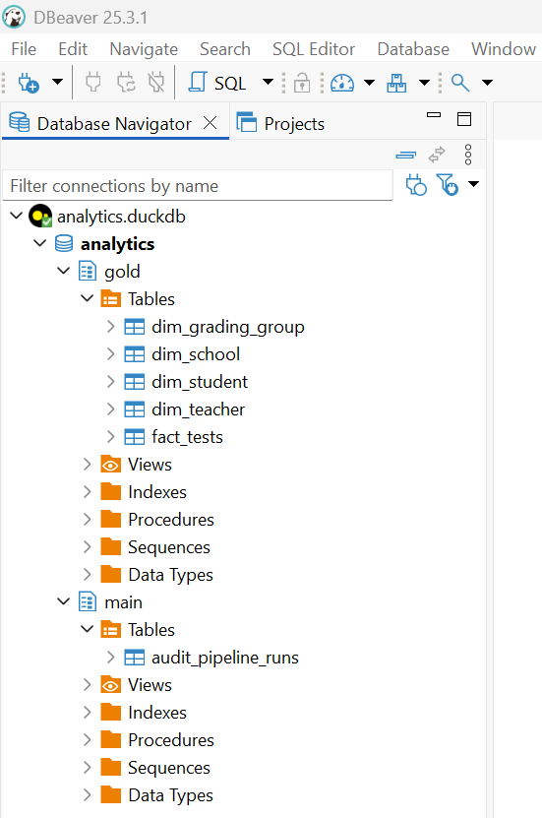

DB Schematics (Star Schema)

